Multi-Tier WordPress Architecture on AWS

Project Overview:
This project demonstrates a scalable, fault-tolerant WordPress deployment using AWS services. It follows a multi-tier architecture pattern with separate layers for compute, storage, and database, built entirely using CloudFormation templates.

Objectives:
- Deploy WordPress across multiple Availability Zones
- Use CloudFormation for infrastructure automation
- Enable auto scaling and load balancing
- Integrate Amazon EFS for shared storage
- Connect WordPress to Amazon Aurora (RDS) backend
- Validate full-stack deployment via ALB DNS

Architecture Summary:
Network Layer: VPC, Subnets, IGW, NAT Gateway
Compute Layer: EC2 (Launch Template with User Data)
Storage Layer: Amazon EFS
Database Layer: Amazon Aurora (MySQL-compatible)
Routing Layer: Application Load Balancer
Scaling Layer: Auto Scaling Group
Security Layer: IAM Roles, Security Groups

Key Skills Demonstrated:
- Infrastructure as Code (IaC) using CloudFormation
- Multi-AZ architecture with high availability
- Troubleshooting ALB health checks and EC2 connectivity
- EFS integration with WordPress
- Security group configuration and IAM role usage
- End-to-end deployment validation
Screenshot Highlights:
- CloudFormation stack creation
- VPC and subnet setup
- RDS cluster configuration
- EFS mount targets
- ALB and target group health checks
- EC2 instances in service
- WordPress login and dashboard access

Summary:
Designed and deployed a fault-tolerant AWS architecture using CloudFormation, spanning multiple Availability Zones. Implemented a highly available Amazon RDS instance, integrated Amazon EFS for shared NFS storage, and configured auto-scaling web servers for dynamic load handling. Demonstrated expertise in cloud infrastructure, documentation clarity, how and what are the requirements to solve a real-world business problem. Now that I’m familiar with concepts and services, this project solidifies my knowledge a lot.

- AWS Cloud Multi-Tier Architecture (Visual representation of the system flow):
Internet → Internet Gateway → Application Load Balancer → Auto Scaling Group (EC2 in App Subnets) → Amazon EFS (Shared Storage)
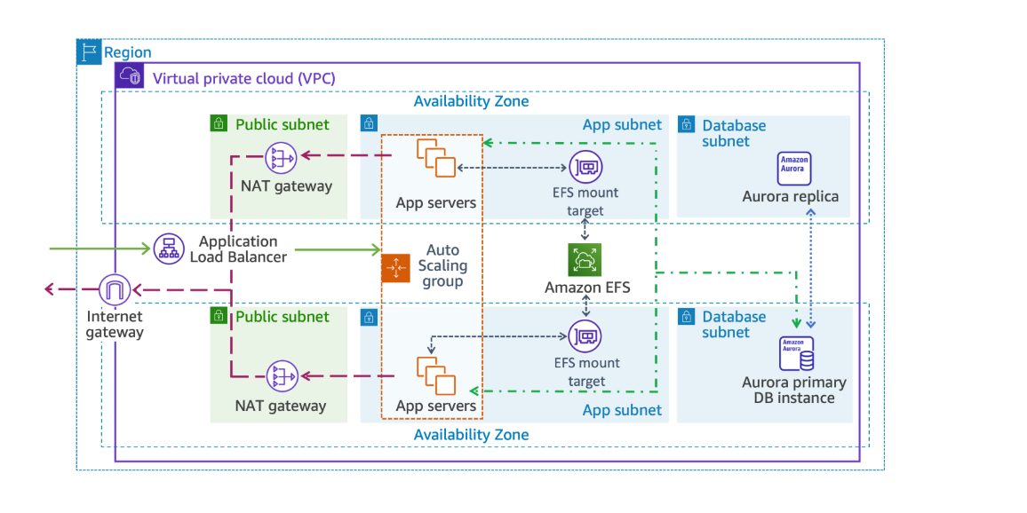

- CloudFormation Stack Deployment
Successfully deployed VPC, subnets, route tables, NAT gateway, and security groups using CloudFormation.
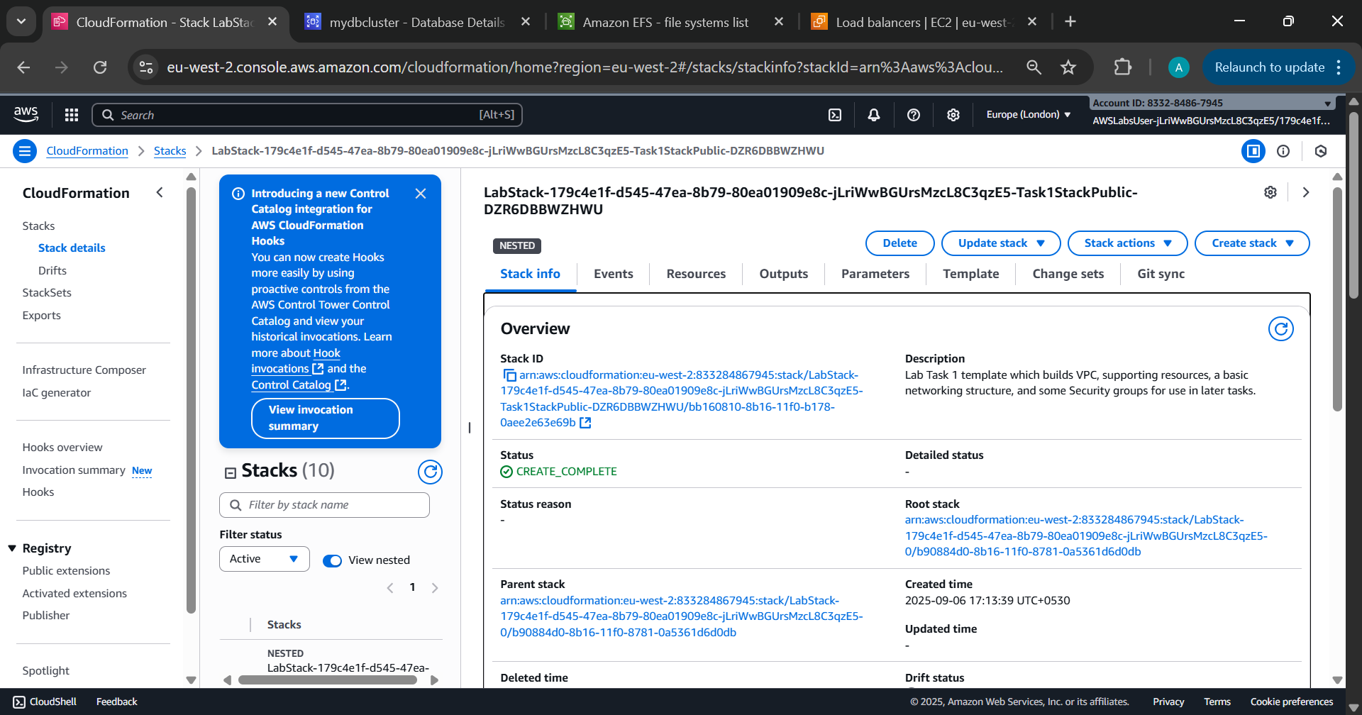

- Amazon Aurora Cluster Setup
Multi-AZ Aurora database cluster provisioned for high availability and fault tolerance.
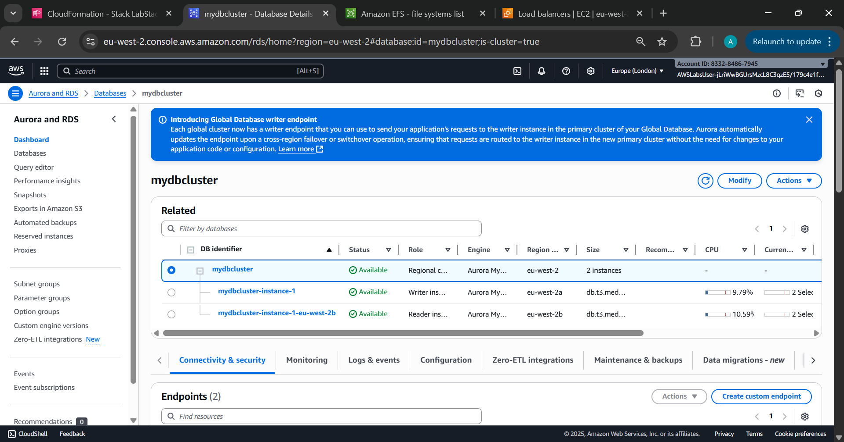

- Elastic File System Creation
Amazon EFS file system created to provide shared storage across application instances.

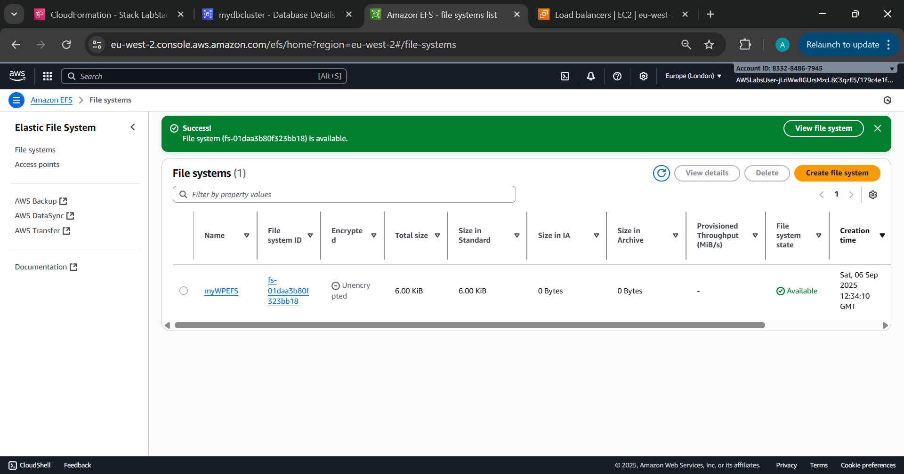

- Target Group Health Check Setup
Health check path configured as /wp-login.php to monitor WordPress application status.
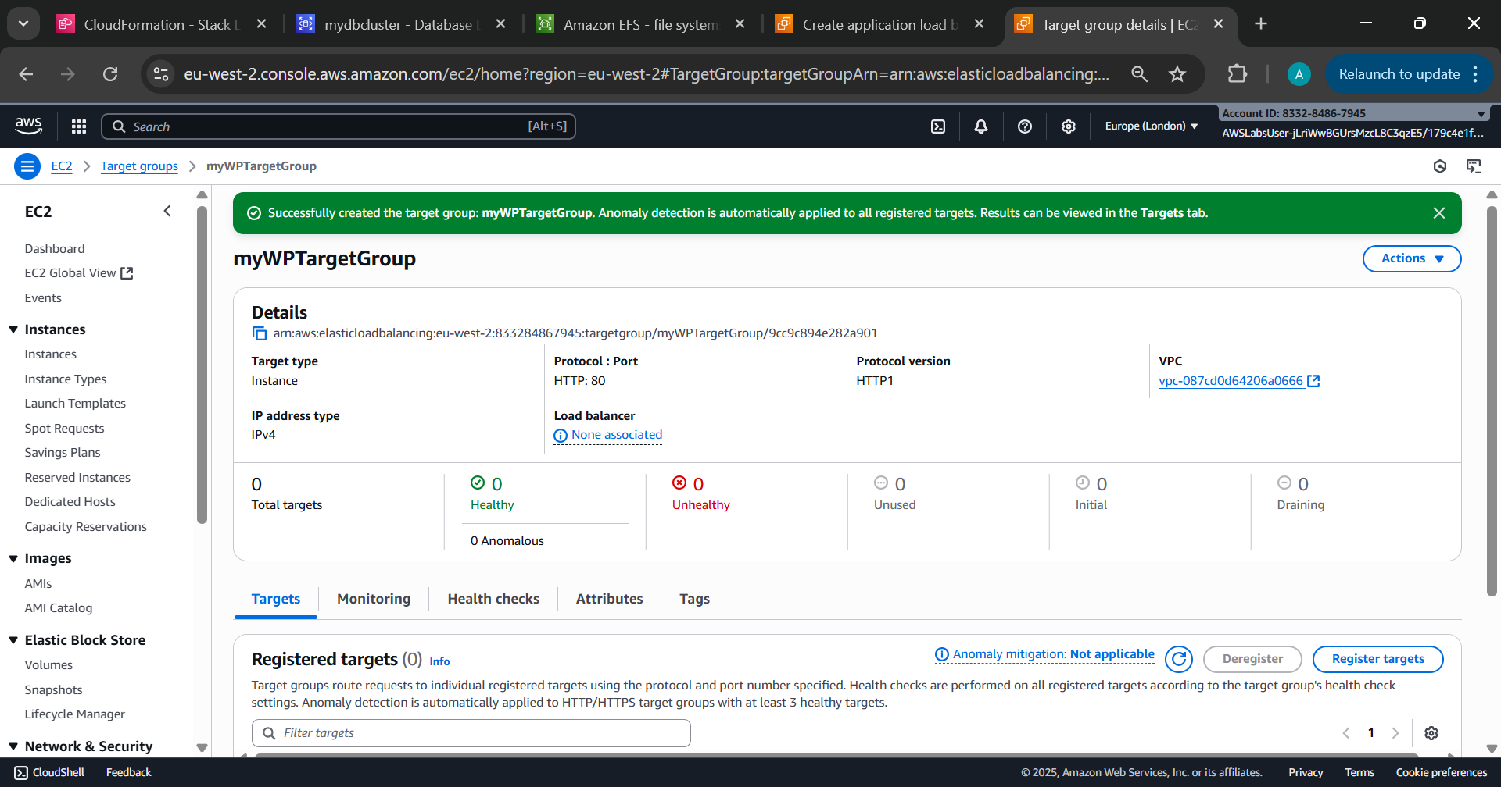

- Application Load Balancer Listeners Setup
ALB provisioning Listener and routing settings incoming traffic to EC2 instances.
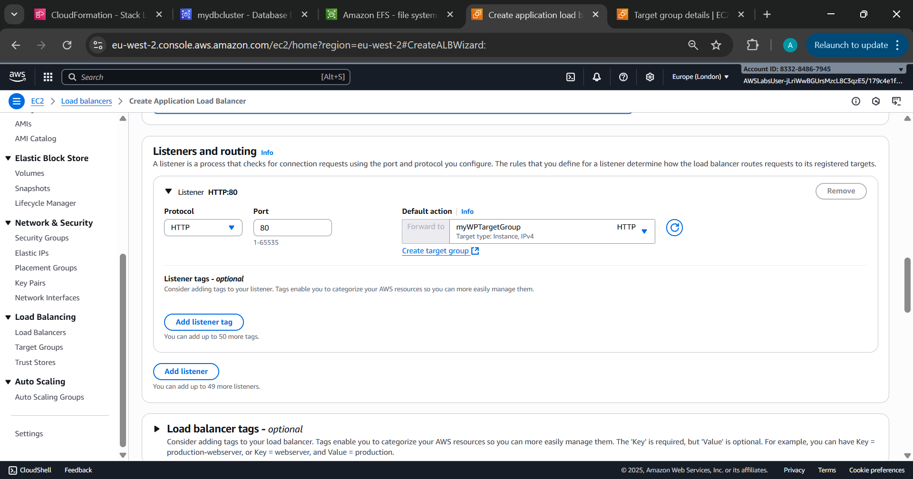

- Application Load Balancer Deployment
ALB provisioned across public subnets to distribute incoming traffic to EC2 instances.
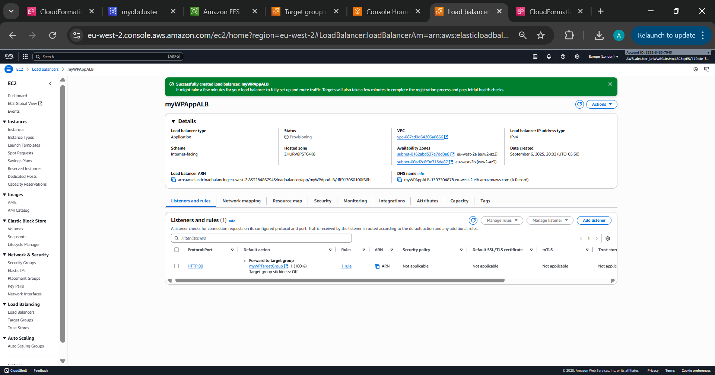

- Launch Template Parameters Overview
Parameters passed during stack creation including database endpoint, EFS ID, and ALB name.

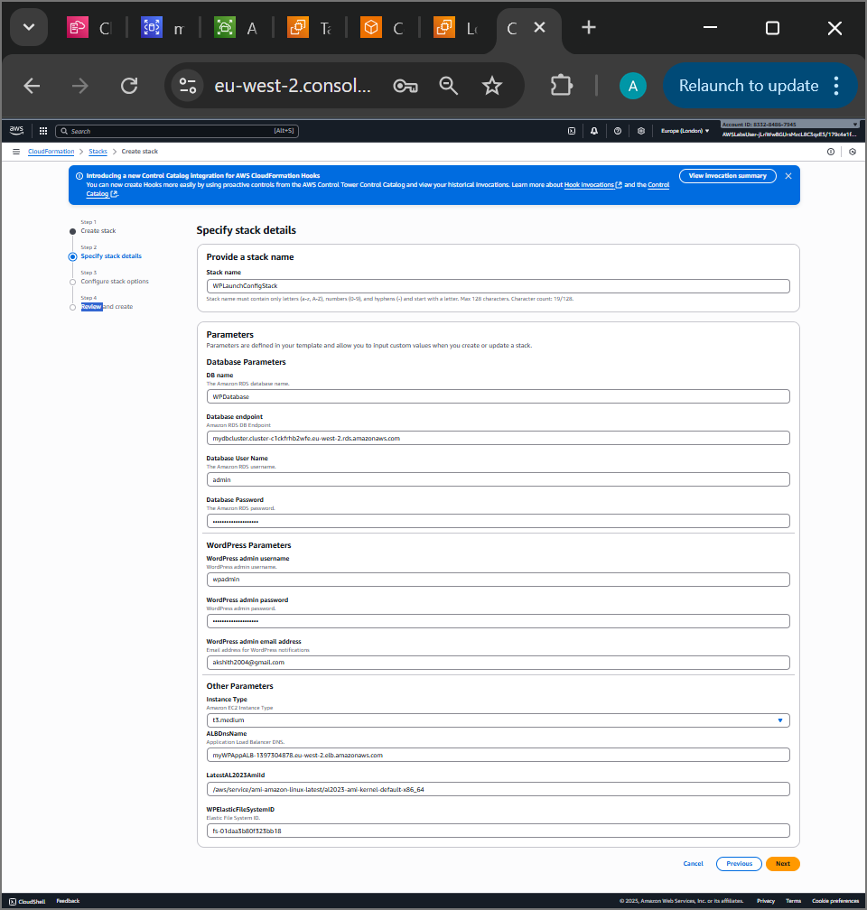

- Launch Template Stack Creation
Launch template created with WordPress user data and EFS mount instructions for EC2 instances.
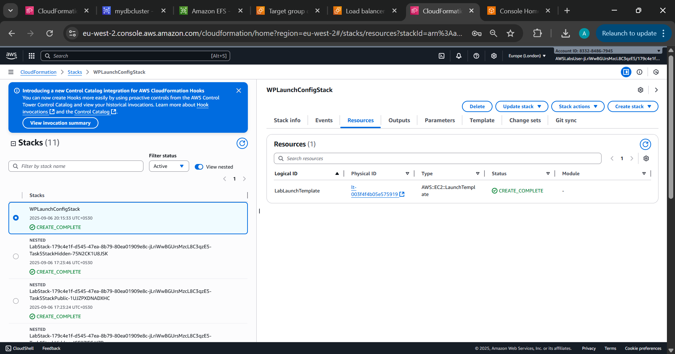

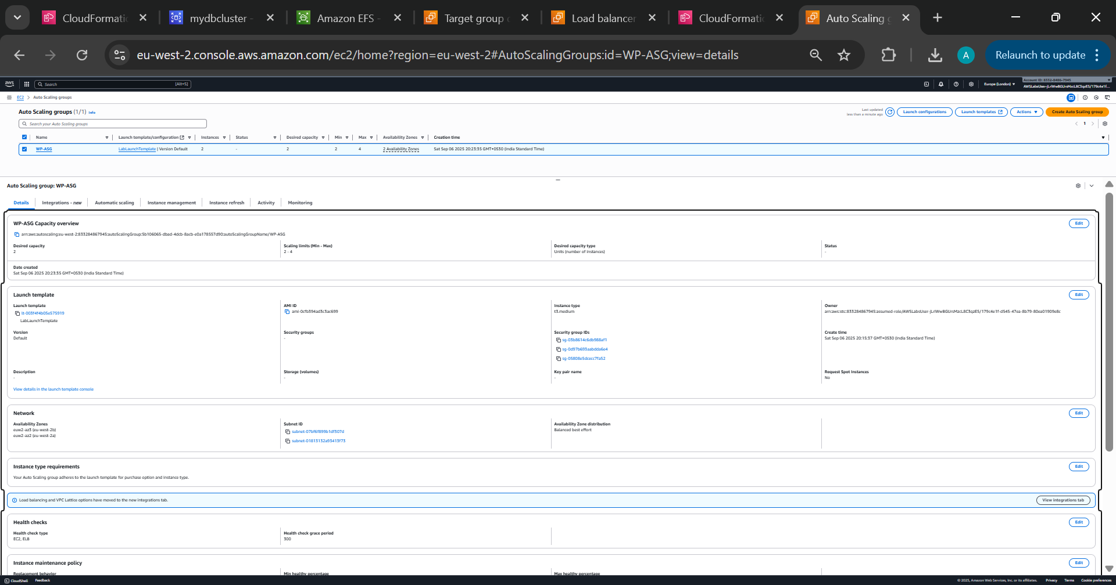

- ALB DNS name verified and ready for routing external traffic to the application tier.
WordPress Login Page Access
WordPress login page successfully accessed via ALB DNS, confirming front-end availability.
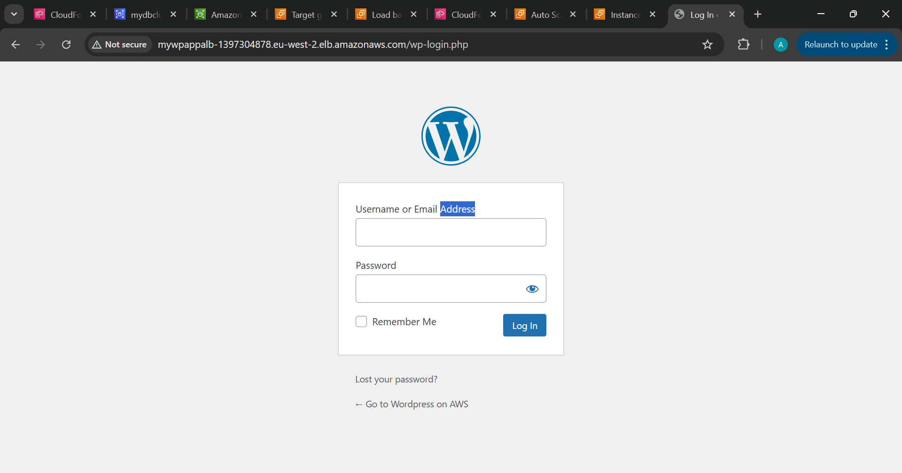

- Application Working
WordPress Admin Dashboard Access
Logged into WordPress admin panel, validating full-stack deployment and application readiness.

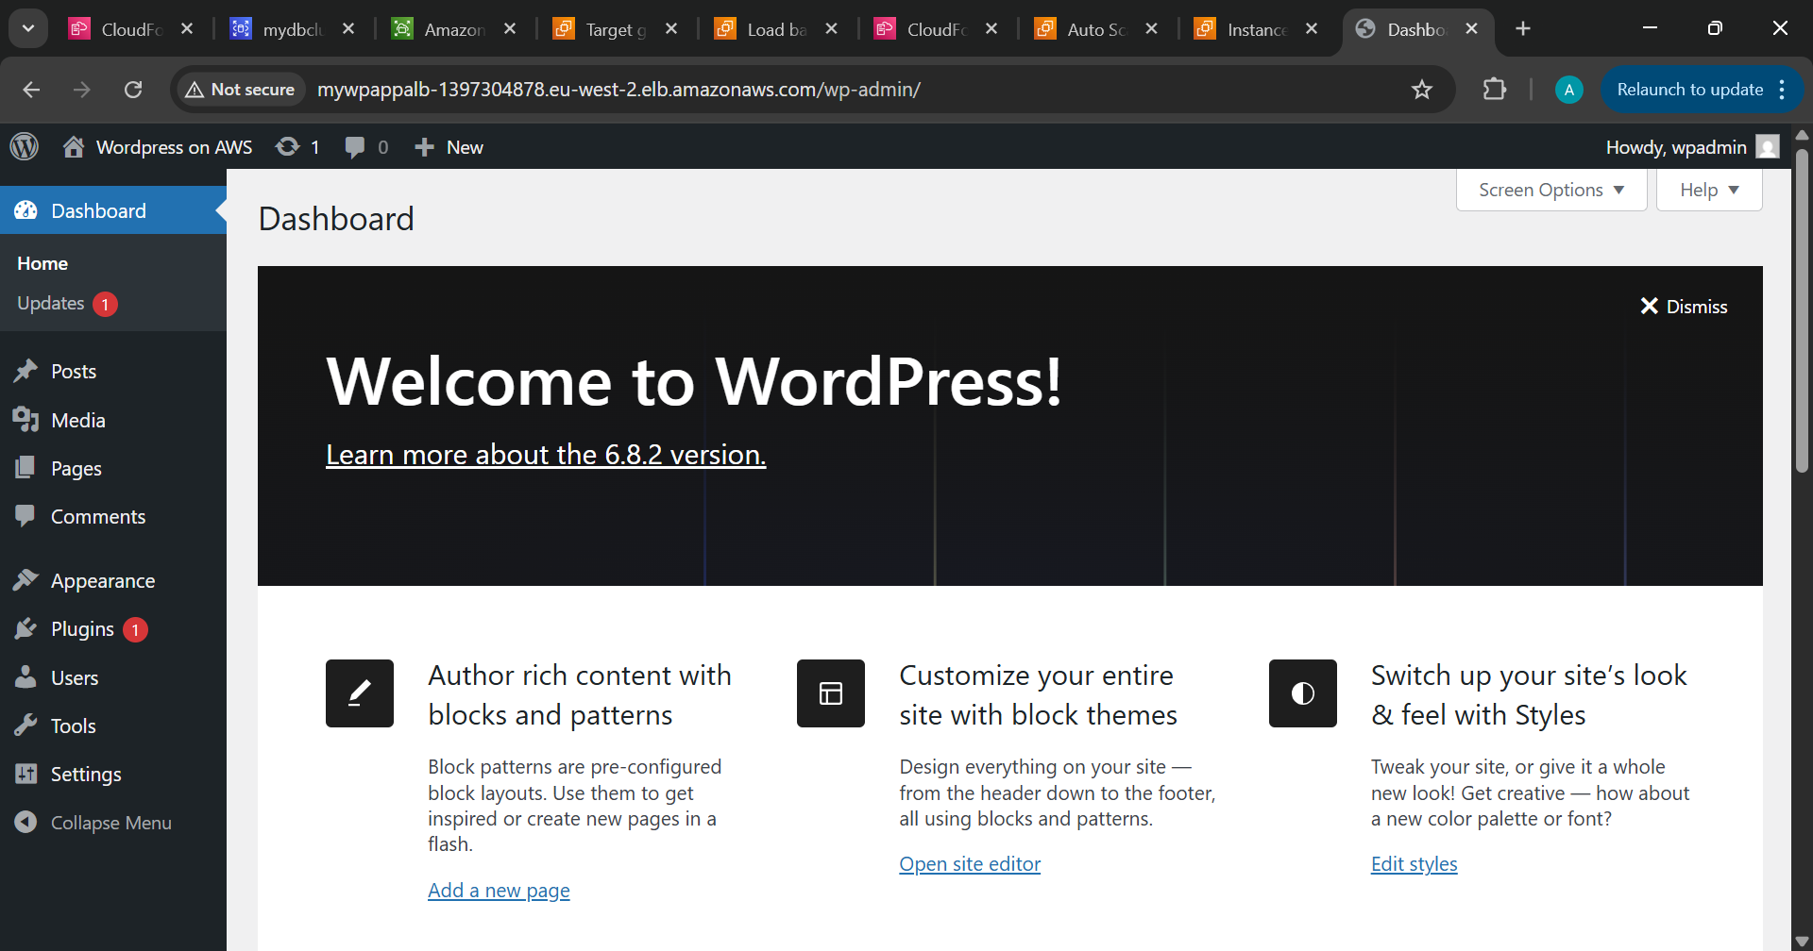
Therefore:
- Deployed a virtual network spread across multiple Availability Zones in a Region using a CloudFormation template.
- Deployed a highly available and fully managed relational database across those Availability Zones using Amazon RDS.
- Used Amazon EFS to provision a shared storage layer across multiple Availability Zones for the application tier, powered by NFS.
- Created a group of web servers that automatically scales in response to load variations to complete your application tier.

